WEEK-2
Exercise 1: Control Structures
1) IF-ELSE
CODE:
SET SERVEROUTPUT ON;
DECLARE
marks NUMBER;
BEGIN
marks := 95;
IF marks >= 90 THEN
DBMS_OUTPUT.PUT_LINE('Grade: A');
ELSIF marks >= 75 THEN
DBMS_OUTPUT.PUT_LINE('Grade: B');
ELSIF marks >= 60 THEN
DBMS_OUTPUT.PUT_LINE('Grade: C');
ELSE
DBMS_OUTPUT.PUT_LINE('Grade: F');
END IF;
END;
/
OUTPUT:
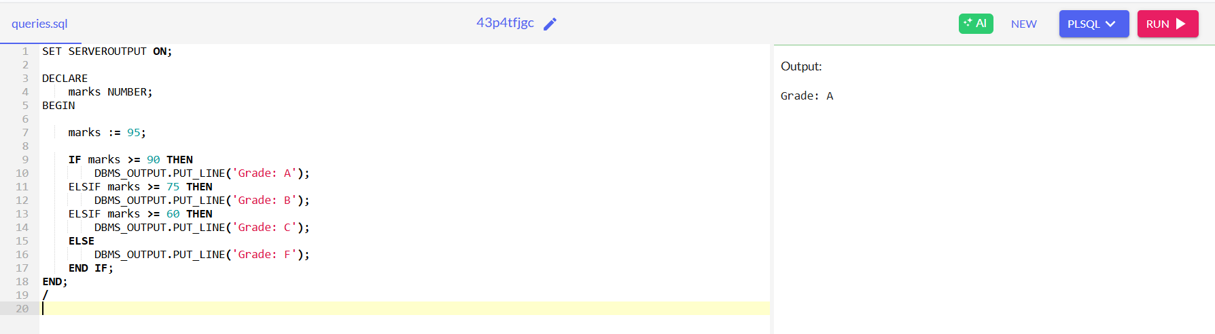

2) CASE Statement
CODE:
DECLARE
dept_id NUMBER := 10;
BEGIN
CASE dept_id
WHEN 10 THEN DBMS_OUTPUT.PUT_LINE('Department: HR');
WHEN 20 THEN DBMS_OUTPUT.PUT_LINE('Department: Finance');
WHEN 30 THEN DBMS_OUTPUT.PUT_LINE('Department: IT');
ELSE DBMS_OUTPUT.PUT_LINE('Unknown Department');
END CASE;
END;
/
OUTPUT:
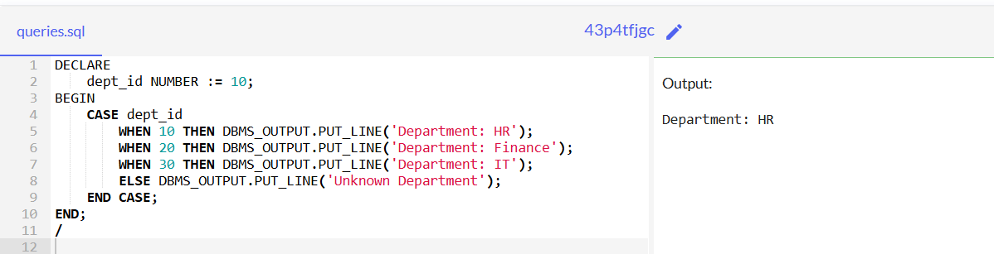

3) WHILE Loop

CODE:
DECLARE
counter NUMBER := 1;
BEGIN
WHILE counter <= 5 LOOP
DBMS_OUTPUT.PUT_LINE('This is PL/SQL: ' || counter);
counter := counter + 1;
END LOOP;
END;
/

OUTPUT:
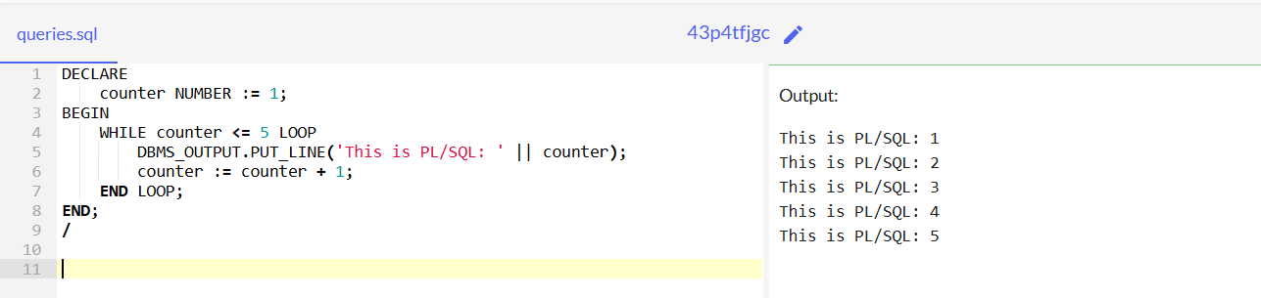

4) FOR Loop
CODE:
BEGIN
FOR i IN 1..7 LOOP
DBMS_OUTPUT.PUT_LINE('Iteration count: ' || i);
END LOOP;
END;
/
OUTPUT:
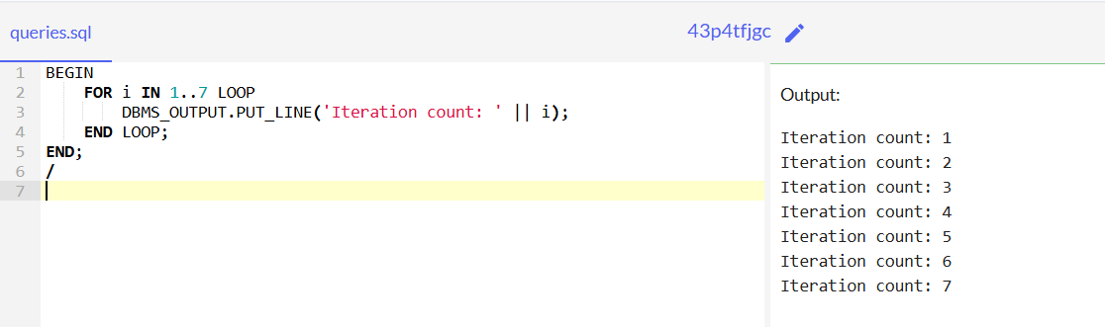

5) EXIT
CODE:
DECLARE
i NUMBER := 1;
BEGIN
LOOP
DBMS_OUTPUT.PUT_LINE('Inside Loop count: ' || i);
IF i = 3 THEN
EXIT;
END IF;
i := i + 1;
END LOOP;
END;
/
OUTPUT:
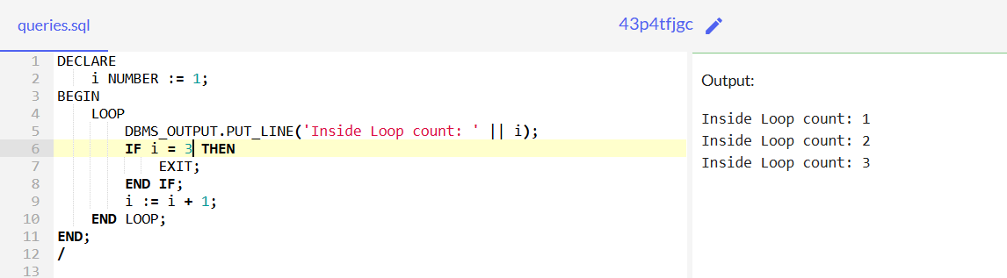

6) CONTINUE
CODE:
BEGIN
FOR i IN 1..5 LOOP
IF i = 3 THEN
CONTINUE;
END IF;
DBMS_OUTPUT.PUT_LINE('Value: ' || i);
END LOOP;
END;
/
OUTPUT:
